Heather Hopkins

WDD130 – W03 Project: Rafting Site – Planning Document

1. Logo

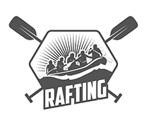

<https://byui-cse.github.io/wdd130-ww-course/resources/images/logos/z-raftingbw.png>

2. Colors

* primary-color: Oxford Blue #0C1531
* secondary-color: Castleton #Green 0A5C43
* accent1-color: Antique White #FFECD6
* accent2-color: Raisin Black #2E2E38

3. Fonts

* heading-font: Oswald
* text-font: Inter

4. Color Link

<https://coolors.co/0a5c43-2e2e38-0c1531-fff8f0-ffecd6>